MEETING FACILITIES
(Level 2)
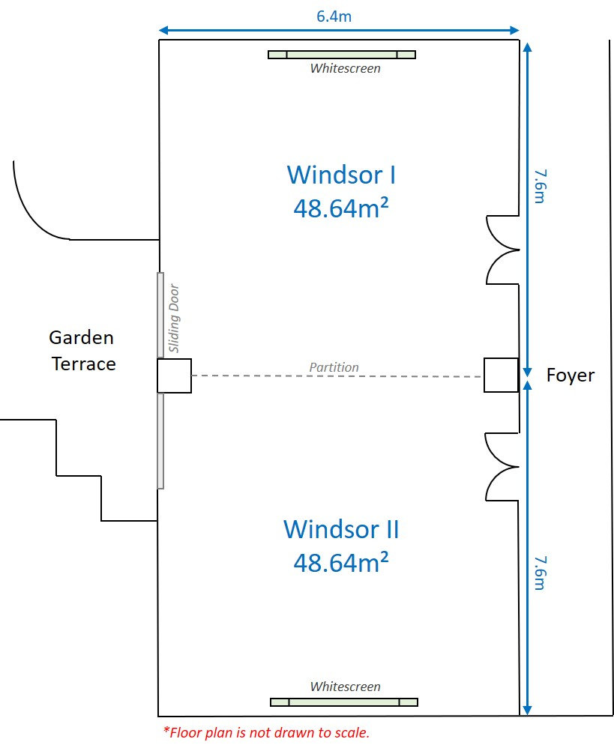
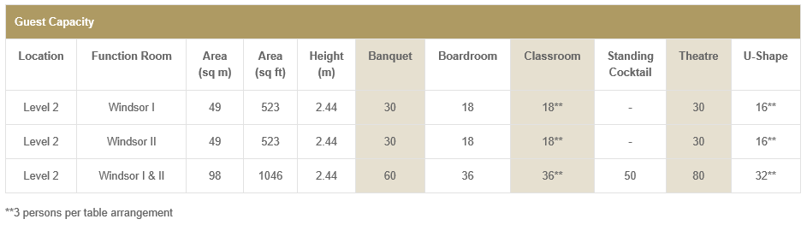

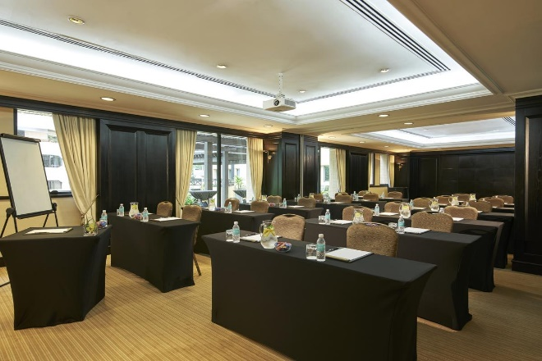 | Classroom style  Table of 3 persons each
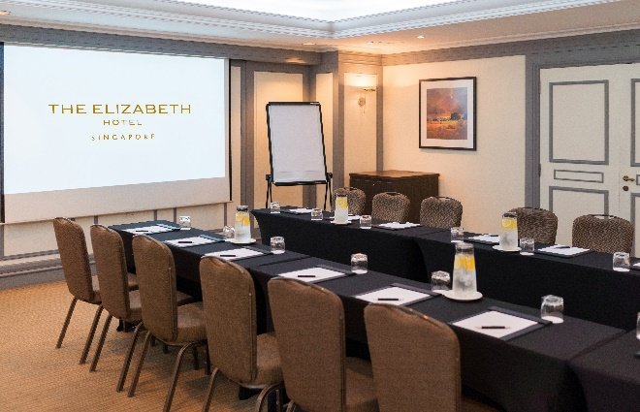 | U-shaped
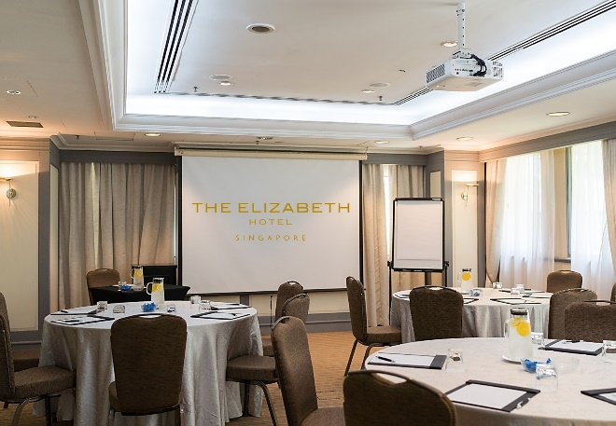 | Cluster  Table of 5-6 persons each
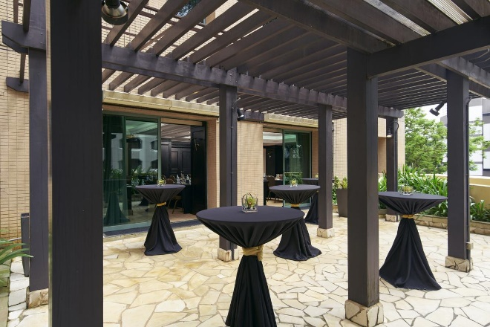 | Garden Terrace (accessible by both function rooms, shared area)

